Name: Tran Khanh Tai
ID: ITITIU21300
Github: KhanhTaiTran/Web-Application-Lab
Lab 8 inclass:
Test 1: Get All customers:
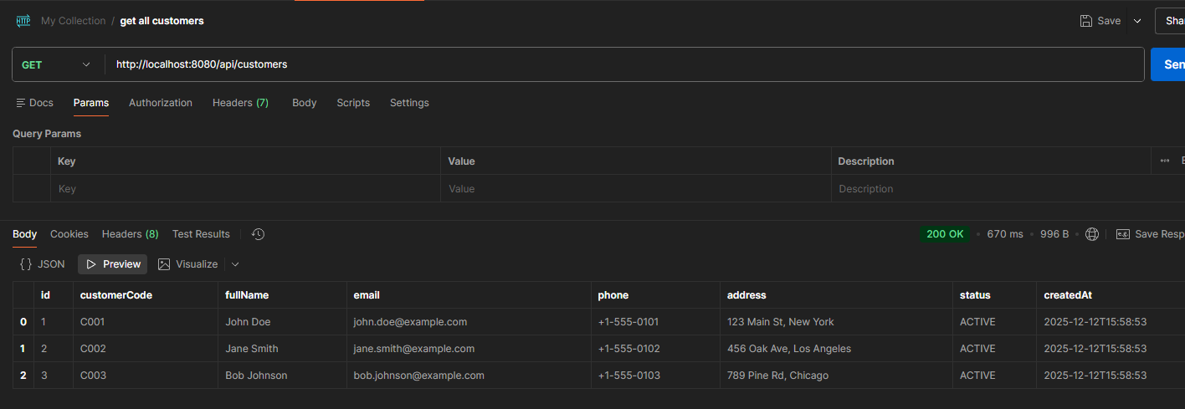
Test 2: GET customer by ID
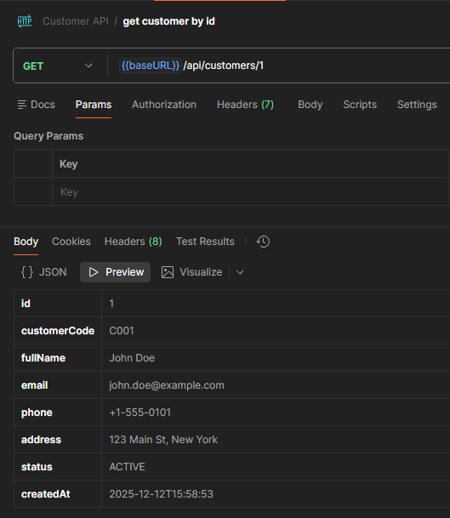
Test 3: POST create customer
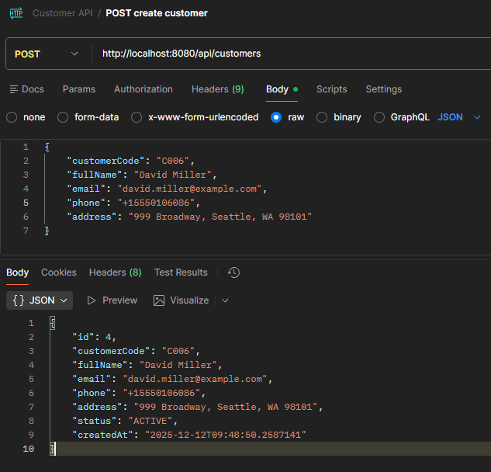
Test 4: PUT update customer
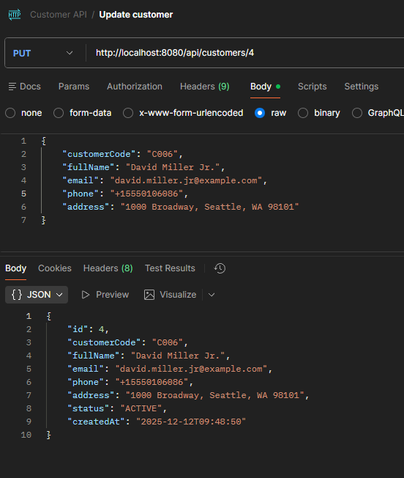

Test 5: Delete customer
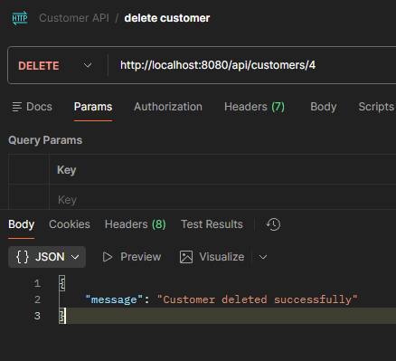
Test 6: Search customers:
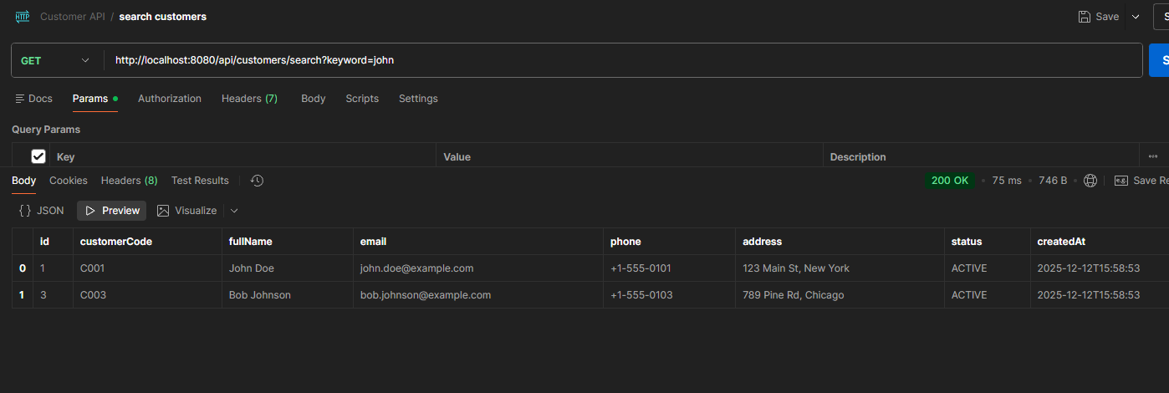

Test 7: Validation Error
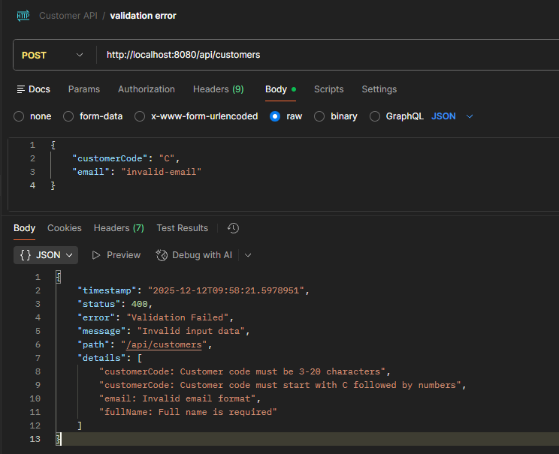

Test 8: Resource not found
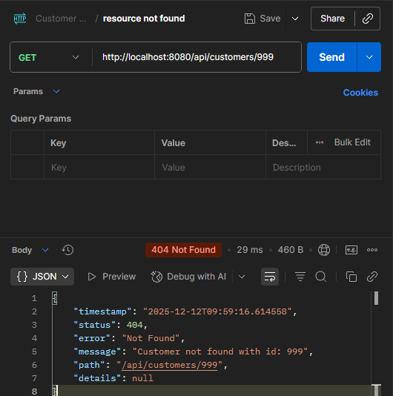

Test 9: Duplicate resource
